**Project Design Phase**

**Solution Architecture**

|  |  |
| --- | --- |
| Date | 9 February 2026 |
| Team ID | LTVIP2026TMIDS91648 |
| Project Name | Gemini Historical Artifact Description |
| Maximum Marks | 4 Marks |

Solution architecture is a structured process that bridges the gap between the problem of generating well-organized historical artifact descriptions and the technology used to automate this task.

For the Gemini Historical Artifact Description System, the solution architecture ensures that user requirements (artifact name, historical period, word count) are effectively transformed into structured, AI-generated artifact descriptions.

Its goals are to:

● Identify the best technological approach (Streamlit + Python + Google Gemini API) to generate structured historical artifact descriptions efficiently.

● Define the overall system structure, including presentation layer (UI), application layer (Python logic), API integration layer (Gemini API), and infrastructure layer (local/cloud deployment).

● Specify functional features, such as input validation, prompt construction, AI-based content generation, structured content display, Markdown export, and error handling.

● Outline development phases, including requirement analysis, system design, implementation, testing, and deployment.

● Provide clear technical specifications, including API integration workflow, prompt engineering strategy, session management, and security mechanisms (API key management).

● Ensure scalability and maintainability, allowing future enhancements such as multi-language support, citation generation, PDF export, or integration with museum databases.

**Solution Architecture Diagram:**

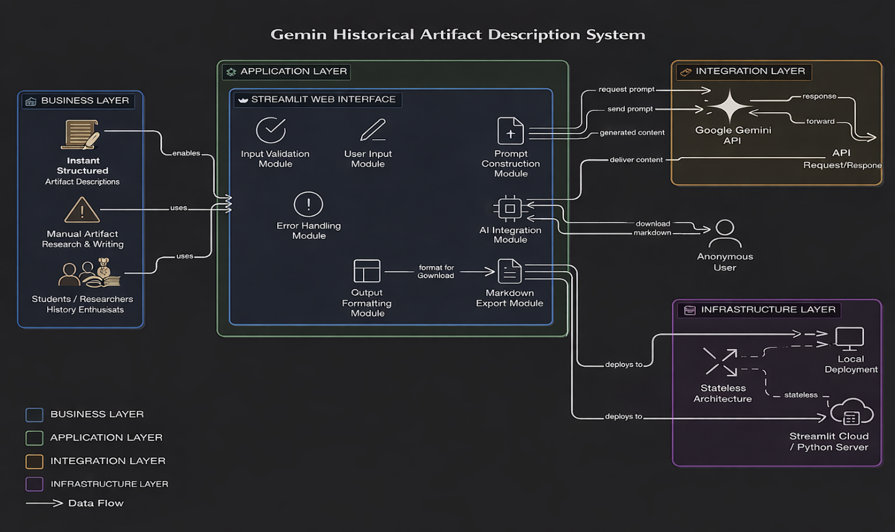

*Figure 1: Architecture and Data Flow of the Gemini Historical Artifact Description*